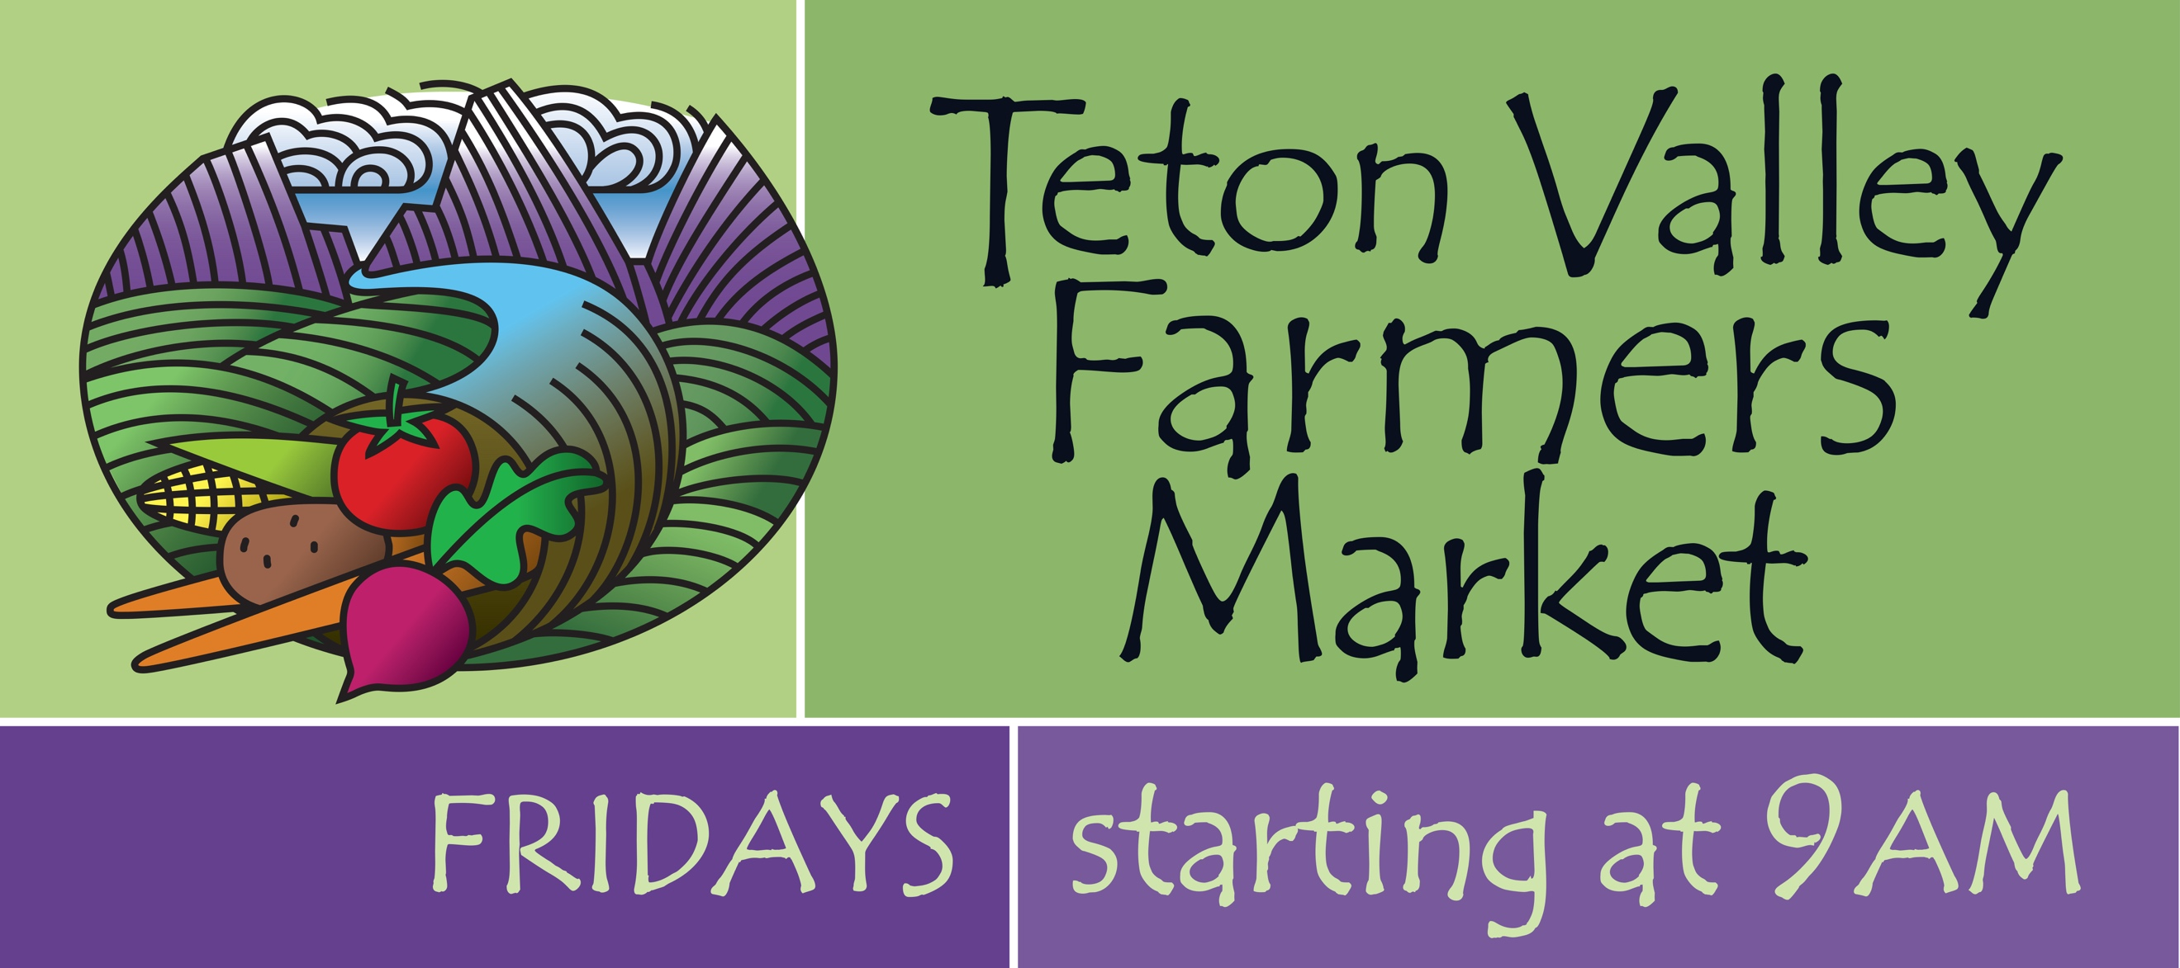

Teton Valley Farmers Market (TVFM) 2023

Vendor Policies and Guidelines

TVFM’s Mission: To provide a venue for local farmers, food producers, artisans and non-profit organizations to connect with the public in order to enhance the health, economy, and vibrancy of the community through commerce and education.

Location and Hours of Operation​:

TVFM is held every Friday morning at the Driggs City Plaza from the first Friday in June through the first Friday in October. Hours of operation are 9am - 1pm. Vendors should arrive by 8am or earlier to set up and be ready for sales by 9am. All vendors are expected to remain set up and present until 1:00pm. We plan to have music every week, either live or taped. Stay tuned for special event dates!

Market Manager:

​ Our Market Manager will be present at every Market to assist the vendors. Please be sure to address any Market-related issues with the Market Manager directly, especially if you will NOT be at some/any of the upcoming Markets you have signed up for.

Vendor Selection Process and Criteria:

The Teton Valley Farmer’s Market selection committee is comprised of the Market Manager and the members of the TVFM Board. They shall evaluate all vendor applications using the following criteria:

- We welcome local and regional (within a 150-mile radius) vendors who wish to provide high-quality, local culinary products such as vegetables, fruits, cheeses, meats, eggs, and locally-made prepared foods such as humus, cider, honey, baked goods, and sauces. In addition, locally-grown cut flowers and plant starts are also accepted. Space allocation for the above food products is 70-75% of the total Market space. The remaining Market space is apportioned among local artisans (jewelry, ceramics, pottery, paintings, and fabrics), non-profits, and breakfast and lunch providers.
- The Market committee strives for a balanced variety of offerings.
- The Market complies with all Federal, State, and City non-discrimination policies and laws.
- Teton Valley and returning vendors have first preference. Others within the above radius have second preference. We expect the vast majority of what each booth sells be grown or created by the vendor. All items in your booth must be pre-approved by the Market Manager prior to the first Market. Please have a sign with your name or your farm’s clearly displayed at your booth on Market day.
- We have many returning vendors in our limited space, and will admit new vendors as space allows.
- In cases where certain categories of goods are not available from local producers (such as fruits, fish, and corn), outside producers and/or products are welcome.
- Applications for space at the Market are due by April 1st of each year. Applicants will be notified of their acceptance or rejection by April 30th. The committee will entertain one appeal of its decision of rejection. Rejected entities can join the Market waiting/fill-in list if they wish.
- No dogs or other pets permitted to accompany vendors without special permission from the Farmer’s Market Board and Market Manager.
- The Market holds all its vendors to high standards of performance:
- Arrive on time.
- Be ready for business at 9:00 a.m.
- Provide quality products and friendly service.
- After breakdown, leave the Plaza perfectly clean.
- Bring any issues to the Manager and/or Board, and work productively to solve them.

Market Fees​: Fees for 2023 are:

Single Booth/Season = $150. Single booth/one week = $30; two weeks = $60, three weeks = $90; four weeks = $120; five or more weeks $150.
Double Booth/Season = $300. Double booth/one week = $60; two weeks = $120; three weeks =$180; four weeks = $240; five or more weeks = $300.
Non-profits selling items = $30/day (all sale items must be Manager-approved beforehand).
Non-profits not selling items and Kids’ booths (under 16 years old) may have free space.

Your Market fees cover the cost of the Market’s liability insurance, annual City fee for the Plaza for the season, the Market Manager’s salary, ads, music, and more.

Please note: we cannot accommodate more than either one single or one double booth per vendor. Please make checks payable to Teton Valley Farmers Market by the first Market. Our mailing address is Teton Valley Farmer’s Market, PO Box 410, Driggs, Idaho 83422. Or, you may pay by Venmo. Upon our receiving payment, you will be assigned a spot for your booth(s) for the week(s) or for the season.

Market ‘No-Show’ Fees:

For our Market to be the best it can be given our limited space and high demand, we charge a fee of $50 if you fail to show on Market day without letting the Manager know at least 48 hours in advance of your proposed absence. This applies to artisans as well as food vendors. Teton Valley Farmer’s Market Email = tetonvalleyfarmersmarket@gmail.com

Health and Safety:

Health Department –

- Produce (fresh fruits and vegetables): The Health Department requires no special license.
- Processed Foods: All processed food items will need either a Temporary Event License, or a Cottage Foods Assessment from the District 7 Health Department. These applications may be found on their website:
http://www.phd7.idaho.gov/EH/Food/foodprogramresources.html
Any paperwork needs to be submitted to the Health Department 2 weeks prior to the first Farmer’s Market for a timely turnaround.
- For all non-exempt prepared foods, work with the Health Department to obtain your license.
- Cottage Foods are foods made in a person’s home or other designated location and sold directly to the consumer. These foods include baked goods, jams, honey, dried fruits, etc. If you are planning to sell any of these items, please fill out a Cottage Foods Assessment, and submit it to the Health Department.

Please contact Eric Baird, the new Teton County Food Program Health Inspector if you have any questions: (208)-356-3239; or ericbaird@eiph.idaho.gov

- For Safety – We insist you bring and use substantial weights every week for your tent(s). Significant wind gusts often visit the Plaza without warning. They will send your tent(s) aloft a la Mary Poppins! We all must be mindful of injuries to visitors and vendors as well as damage to other vendors’ tents.

Eggs & Nursery Items:

Eggs may be sold without a permit if you have less than 300 birds. Egg cartons need to be labeled with the producer’s name, address, and say “Ungraded Eggs”.

For cut flowers, potted plants, and herb/vegetable starts, you will need to obtain a nursery license through the Department of Agriculture in Boise if you are selling over $500 of these items during a calendar year.

Selling by Weight:

Farmers selling items by weight should have an approved scale (one that says Legal for Trade Class 111 or better with a current license.) Please post in your booth the price per pound of all items you are selling by the pound. Or, you can pre-package items at home with any scale, or sell them By Count or By Measure. Please direct questions to the Idaho Weights & Measures Department at (208)-332-8690.

At Your First Market:

Touch base with the Market Manager right away to be assigned a space. Unload your supplies quickly, and move your vehicles around to the back of the City Center prior to setting up your booth. This clears the way for other vendors to unload and for customers to park when the Market opens. Please ensure your tents are well-anchored!! We expect you to present a neat, attractive booth with prices marked clearly for customer convenience and efficiency. For all baked goods, please list ingredients due to increased concern about allergies. Please note: the Market does NOT supply power cords. If you do require a power source, please inform the Manager at the time of application so he/she may assign you a spot near a Plaza outlet.

Liability Insurance:

We encourage vendors to carry their own liability insurance. The Market has a general liability policy.

And, The Tax Man:

Although our Teton Valley Farmer’s Market does not ask for a percentage of your sales, you will need to pay a 6% State tax on all your sales. The City of Driggs also collects a 0.5% tax. You can get forms at the Market, or by mail or email.

You will also need to have a No-Cost Seller’s Permit you can obtain from the Idaho Tax Commission. You’ll need to fill out an IBR-1 form to apply for this permit. Please contact the Idaho Tax Commission in Boise at: (208)-334-7660, or (800)-972-7660. Or, you may go to their website: www.tax.idaho.gov

