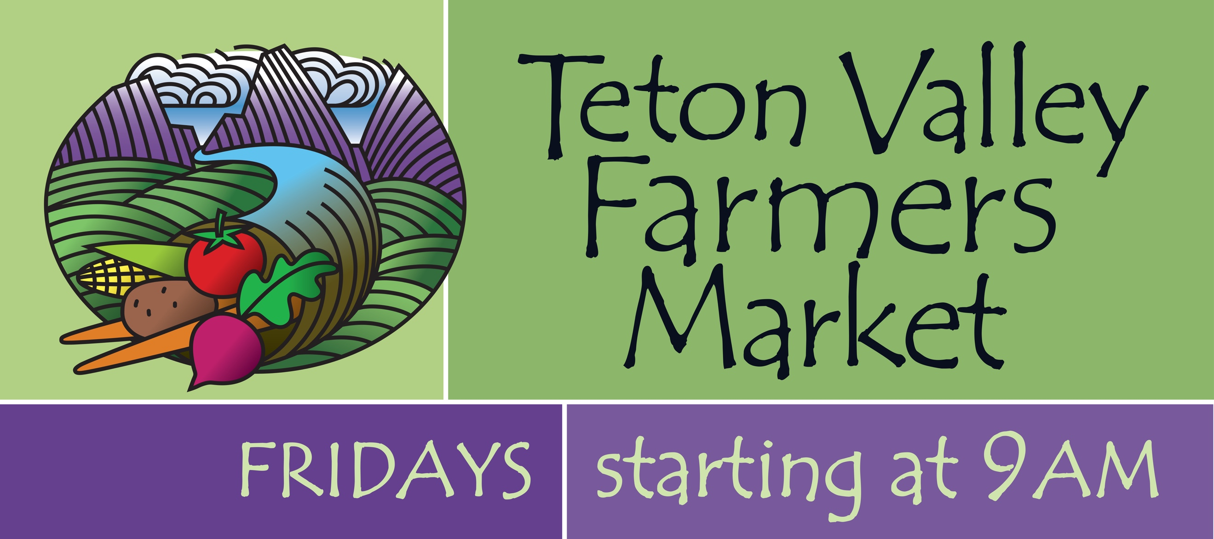

Teton Valley Farmers Market 2020

Vendor Policies and Guidelines

Mission: The Teton Valley Farmer’s Market strives to provide a venue for farmers, food purveyors, and artisans to have a direct connection to the community through commerce and education.
Vision: The Market desires to promote a sustainable community event where the public can learn about the relationship of our local farms and food to the overall health and economy of our Valley.

Location and Hours of Operation​:

Our Market is held every Friday morning 9am - 1:00pm, June 5th - October ^{2nd}, in front of the Driggs City Building at 60 South Main Street in Driggs. Vendors should arrive by 8am or earlier to set up and be ready for sales by 9am. All vendors are expected to remain set up and present until 1:00pm. We plan to have music every week, either live or taped. Stay tuned for special event dates! If you plan to bring along a canine partner, please remember all dogs must be on leashes per City code.

Market Manager:

​Karen Lowenthal is our market manager. Karen will be present to assist vendors at every market. Please be sure to address any Market-related issues with the Market Manager, especially if you will NOT be at some/any of the upcoming Markets.

Vendor Selection Process and Criteria:

The Teton Valley Farmer’s Market selection committee, comprising of a balance of vendor and non-vendor Market Board members, evaluates all vendor applications using the following criteria:

- We welcome local and regional (within 150-mile radius) vendors who would like to provide high-quality, local culinary products such as vegetables, fruits, cheeses, meats, eggs, and locally-made prepared foods such as humus, cider, honey, baked goods, and sauces. In addition, locally-grown cut flowers and plant starts are also accepted. Space allocation for the above food products is 70% of the total Market space. The remaining Market space is apportioned among local artisans (jewelry, ceramics/pottery, paintings, and fabrics), non-profits, and lunch providers. (Note: The City of Driggs limits the number of artisans)
- As the committee evaluates vendor applications, it aims for a balanced variety of offerings.
- The Market complies with all Federal, State, and City non-discrimination policies and laws.
- Teton Valley and returning vendors have first preference; those others within the above radius have second preference. We expect the vast majority of what each booth sells be grown or created by the vendor. All items in your booth must be pre-approved by the Market Manager. Please have a sign with your name or farm’s and your town of location clearly displayed at your booth on Market day.
- In cases where certain categories of goods are not available from local producers (such as fruits, fish, and corn), outside producers and products are welcome.
- We have many returning vendors in our limited space, and will admit new vendors as space allows.
- Applications for space at the Market are due by April 1st of each year. Applicant will be notified of their acceptance or rejection by April 30th. The Board will entertain one appeal of its decision of rejection. Rejected entities can join the Market waiting/fill-in list if they wish.
- The Market holds all its vendors to high standards of performance:
- Arrive on time.
- Be ready for business at 9:00 a.m.
- Provide quality products and friendly service.
- After Breakdown, leave the Plaza perfectly clean.
- Bring any issues to the Manager and/or Board, and work productively to solve them.

Market Fees​: Fees for 2020 are:

Single Booth/Season = $120. Single booth/one week = $30, two weeks = $60, three weeks = $80.
Double Booth/Season = $240. Double booth/one week = $50, two weeks = $100, three weeks =$130.
Shared Booth Single/Season = $140; Single/one week = $40.
Shared Booth Double/Season = $270; Double/one week = $70.
Non-profits selling items = $20/day (all sales items must be Manager approved beforehand).
Non-profits not selling items and kids’ booths (under 16 years old) may have free space.

Your Market fees cover the cost of the Market’s liability insurance, annual City fee for the Plaza for the season, ads, music, and more.

Please note: we cannot accommodate more than 2 booths per vendor. Please make checks payable to Teton Valley Farmers Market by April 1st. After payment, you will be assigned a spot for your booth(s) for the week(s) or the season.

Market ‘No-Show’ Fees:

For our Market to be the best it can be given our limited space and high demand, we charge a fee of $50 if you fail to show on Market day without letting the Manager know at least 48 hours in advance of your proposed absence.

Health and Safety:

Health Department –

- Produce (fresh fruits and vegetables): The Health Department requires no special license.
- Processed Foods: All processed food items will need either a Temporary Event License, or a Cottage Foods Assessment from the District 7 Health Department. These applications may be found on their website:
http://www.phd7.idaho.gov/EH/Food/foodprogramresources.html
Any paperwork needs to be submitted to the Health Department 2 weeks prior to the first Farmer’s Market for a timely turnaround.
- For all non-exempt prepared foods, work with the Health Department to obtain your license.
- Cottage Foods are foods made in a person’s home or other designated location and sold directly to the consumer. These foods include baked goods, jams, honey, dried fruits, etc. If you are planning to sell any of these items, please fill out a Cottage Foods Assessment, and submit it to the Health Department.

Please contact Eric Baird, the new Teton County Food Program Health Inspector if you have any questions: (208)-356-3239; or ericbaird@eiph.idaho.gov

- For Safety – We insist you bring and use substantial weights for your tent(s). There are significant wind gusts that visit the Plaza and will send your tent(s) aloft a la Mary Poppins! Not to mention the injuries that may occur during such events.

Eggs & Nursery Items:

Eggs may be sold without a permit if you have less than 300 birds. Egg cartons need to be labeled with the producer’s name, address, and say “Ungraded Eggs”.

For cut flowers, potted plants, and herb/vegetable starts, you will need to obtain a nursery license through the Department of Agriculture in Boise if you are selling over $500 of these items during a calendar year.

Selling by Weight:

Farmers selling items by weight should have an approved scale (one that says Legal for Trade Class 111 or better with a current license.) Please post in your booth the price per pound of all items you are selling by the pound. Or, you can pre-package items at home with any scale, or sell them By Count or By Measure. Please direct questions to the Idaho Weights & Measures Department at (208)-332-8690.

At Your First Market:

Find the Market Manager right away to be assigned a space. Unload your supplies quickly, and move your vehicles around to the back of the City Center where there is ample parking. This clears the way for other vendors to unload and for customers to park when the Market opens. Please ensure your tents are well-anchored (even on calm days; conditions in Teton Valley can change in a trice!) We expect you to present a neat, attractive booth with prices marked clearly for customer convenience and efficiency. For all baked goods, please list ingredients due to increased concern about allergies. Please note: the Market does NOT supply power cords. If you do require a power source, please inform the Manager at the time of application so he/she may assign you a spot near an outlet.

Liability Insurance:

We encourage vendors to carry their own liability insurance. The Market has a general liability policy.

And, The Tax Man:

Although our Teton Valley Farmer’s Market does not ask for a percentage of your sales, you will need to pay a 6% State tax on all your sales. The City of Driggs also collects a 0.5% tax. You will get a form for this at the Market or by mail.

You will also need to have a No-Cost Seller’s Permit you can obtain from the Idaho Tax Commission. You’ll need to fill out an IBR-1 form to apply for this permit. Please contact the Idaho Tax Commission in Boise at: (208)-334-7660, or (800)-972-7660. Or, you may go to their website: www.tax.idaho.gov

Thank You!

Teton Valley Farmer’s Market

Email: tetonvalleyfarmersmarket@gmail.com

Karen Lowenthal, Market Manager: tel. (603) 933-0389

