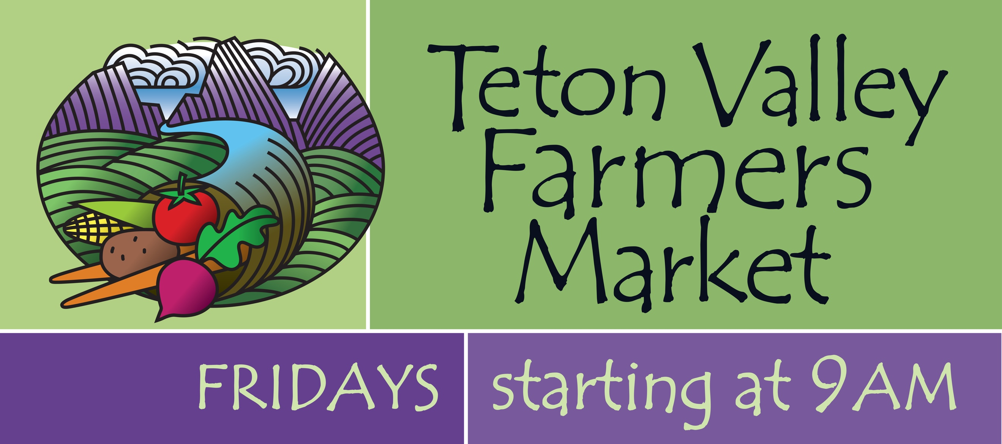

Registration for the 2022 Teton Valley Farmer’s Market

Organization Name (please print):

Contact Person (please print):

Mailing Address:

Phone: Email:

In general, tell us what items and/or activities you plan to have at shall have at your booth:

Market Attendance: Please let us know what week(s) you would like to attend the Market :

June 3rd ____ 10th ____ 17th ____ 24th ____

July 3rd ____ 1st ____8th ____15th ____22nd ____ 29th____

August 5th ____12th ____19th ____ 26th ____

September 2nd ____ 9th ____ 16th ____ 23rd ____ 30th

October 7th ____

All Non-Profits and Kids’ Booth participants attending the Market, please check in with the Market Manager upon arrival to be assigned your booth location.

Please note: If at any time during the season you know you will not be able to make a Market, please contact the Market Manager TWO days prior to the Market you will be missing. This enables us to plan ahead so when Market day arrives, everything will run smoothly – for everyone.

Hold Harmless Agreement:

We, the non-profit , have read and understand the Teton Valley Farmer’s Market’s Policies and Guidelines and agree to abide by them.

We also agree to indemnify and hold harmless the Teton Valley Farmer’s Market, its representatives, and agents from and against all liability, claims, demands, losses, damages, levies, and causes of action or suits of any nature whatsoever, arising out of or related to our activities at the Market.

Non-profit Signature(s): _______________________________________________

Date: ____________________________________________________________

Thank You!

